**FIELD STUDY ON THE IMPACT OF ESL AMONG TAMIL MEDIUM STUDENTS OF XI STANDARD IN GOVT. HR SEC SCHOOL, VALARPURAM**

**A Field Study Submitted to**

**GOVERNMENT ARTS AND SCIENCE COLLEGE,  
ARAKKONAM – 631 051**

**In partial fulfillment of the requirements for the degree of**

**MASTER OF ARTS IN ENGLISH**

**By**

**PRIYANKA.P**

**REG. NO: 35621P02010**

**Under the Guidance of**

**Dr. P. SAMUEL, M.A., B.Ed., M. Phil., Ph.D.,**



**PG DEPARTMENT OF ENGLISH**

**GOVERNMENT ARTS AND SCIENCE COLLEGE  
ARAKKONAM– 631 051**

**JUNE- 2022**

**FORM-A**

TITLE OF FIELD STUDY : **THE IMPACT OF ESL AMONG TAMIL MEDIUM STUDNETS OF XI STANDARD IN GOVT. HR. SEC. SCHOOL, VALARPURAM**

LANGUAGE : English

NAME OF THE CANDIDATE : **PRIYANKA. P**

REG. NO : 35621P02010

AGE : 22

MALE / FEMALE : Female

DEPARTMENT : PG ENGLISH

YEAR / SEMESTER : I/ II

COLLEGE ADDRESS : Government Arts and Science College, Arakkonam – 631 051

RESEARCH SUPREVISOR : **Dr.P. SAMUEL, M.A., B.Ed., M.Phil., Ph.D.,**

**P. PRIYANKA**  
Govt. Arts and Science College  
Arakkonam – 631 051

**DECLARATION**

I, **PRIYANKA.P**, hereby declare that the Field Study entitled **THE IMPACT OF ESL AMONG TAMIL MEDIUM STUDENTS OF XI STANDARD IN GOVT. HR. SEC. SCHOOL, VALARPURAM** is the result of my original and independent research work, carried out under the guidance of **Dr. P. SAMUEL, M.A., B.Ed., M.Phil.,** **Ph.D.,** Assistant Professor & HOD, Government Arts and Science College, Arakkonam and that it has not been submitted for the award of any Degree, Diploma, or Fellowship or any other similar titles of any university or institution previously.

Place : Arakkonam **PRIYANKA.P**

Date :

**DEPARTMENT OF ENGLISH**

**GOVERNMENT ARTS AND SCIENCE COLLEGE**

**CERTIFICATE**

This is to certify that the Field Study entitled **FIELD STUDY ON THE IMPACT OF ESL**

**AMONG TAMIL MEDIUM STUDENTS OF XI STANDARD IN GOVT. HR. SEC. SCHOOL, VALARPURAM** is a bonafied work of **PRIYANKA.P**, Government Arts and Science College, Arakkonam, during the year 2021-2022. It is certified that this Field Study is an original work of the candidate carried out under my supervision.

Signature of the HOD Signature of Research Supervisor

**Dr. P. SAMUEL, Dr. P. SAMUEL,   
M.A., B.Ed., M.Phil.,Ph.D., M.A., B.Ed., M.Phil., Ph.D.,**Assistant Professor & Head Assistant Professor & Head  
Department of English Department of English  
Govt. Arts and Science College Govt. Arts and Science College  
Arakkonam – 631 501 Arakkonam – 631 501

| **SL.NO** | **CONTENTS** | **PAGE NO** |
| --- | --- | --- |
| I  II  III  IV  V  VI  VII  VIII  IX  X  XI  XII | Introduction  Place of Study  Field Study tools  Statistical collection  Need and Purpose of study  Field study work plan  Questionnaire  Photographs  Statistical Analysis  Study Result  Implementing the solution    Conclusion | 1 - 3  3  4  4  4 - 6  7  8 - 11  12 - 14  15  15 – 17  17 - 20  20 - 21 |

**THE IMPACT OF ESL AMONG TAMIL MEDIUM STUDENTS OF XI STANDARD IN GOVT.HR.SEC.SCHOOL, VALARPURAM**

**INTRODUCTION**

English is a global language that connects the people across geographical boundaries. It plays a vital role in erasing the communicative barriers. Still it remains a challenge for non-native speakers to learn to speak and write the language. Especially the students who learn English as a second language feel it difficult to get along with English language skills. Many regional language teachers have the responsibility of assisting the learners to improve their communicative abilities.

Language is a very important means of communication. It is very difficult to think of a society without language. It sharpens people’s thoughts and guides and controls their entire activity. In the case of the mother tongue, the child learns it easily and comfortably. It is due to the favorable atmosphere and by the great amount of exposure to the language. Language learning process is considered as a creative and constructive process. Learning the language is also the process of modifying the behavior of the students to suit the needs of self and society. Language expresses a person’s innate ability and his maturity in handling the environment. Though mother tongue plays an important role in the life of human beings the skill in learning other languages are also equally significant.

They learn English only for the purpose of appearing for the examination. They feel free from language tension once they complete their examination. They are not aware of the fact that listening and reading play a less important role than writing and speaking do. They do not realize that they studied language as a subject in school and college whereas the objective of learning English is much broader than that.

Obviously, this gap makes their learning possibilities even more difficult. English as a Second Language (ESL) is a traditional term for the use or study of the English language by non-native speakers in an English speaking Environment. There are so many factors affect the process of learning a second language including attitude, self confidence, motivation, duration of exposure to the language, classroom condition, environment, family background and availability of competent teachers.

English is accepted as the second language in India. In the words of Gandhi, “English is a language of international commerce, it is the language of diplomacy and it contains many a rich literary treasures”. It tells us about how English has occupied an important place in Indian education. Therefore, to fix the problems concerning to the effective acquisition of ESL (English as a Second language) among Tamil Medium students, this field study takes up the study on the various difficulties faced by ESL students inside and outside the classroom. This study focuses on the various challenges faced by the students and their attitude towards English language among those who study all the other subjects in Tamil. This study also focuses on how acquiring the basic four skills in English language help them to excel in other subjects.

The interview for Students was prepared by the investigator in order to collect the information from the Students regarding English language learning. The interview was constructed for the sample of selected XI Students. The interview included 40 open ended questions. The sample of XI students selected for the study was interviewed to know the problems faced by them in English Language learning through interview. XI ‘A’ group students subjects are Tamil, English, Mathematics, Chemistry, Physics, Biology, Zoology. XI ‘B’ group Students Subjects are Tamil, English, Biology, Zoology, Physics and Chemistry. XI ‘C’ group Students Subjects are Tamil, English, Accountancy, History, Commerce, Economics, in Government Higher Secondary School, Valarpuram.

**BASIC SKILLS OF ENGLISH**

1. Listening
2. Speaking
3. Reading
4. Writing

**IMPORTANCE AND BENEFITS OF ESL**

1. English has today become one of the manor languages of the world.
2. It will be very difficult to ignore English language because of rich literature and scientific and technical nature of the language.
3. It is strongly felt that the English is the only language of preventing isolation from the world.
4. English is given access to the treasure of knowledge.
5. It improves the standard of higher education and helps to gain self confidence.
6. Twenty five percent of the world’s population speaks English at the basic intermediate level.

**PLACE OF STUDY**

Government Higher Secondary School, Valarpuram, Arakkonam - 631003

**FIELD STUDY TOOLS**

1. Population of the Study : Higher Secondary (11th students) level
2. Variables of the Study : The impact of ESL
3. Sample of the Study : 40 (18 boys, 22 girls)
4. Type of the Study : Simple random sampling method
5. Type of Data Collection : Primary data collection
6. Measuring Tools : Questionnaire method (4 point scale)

**STATISTICAL DATA COLLECTION**

The analysis was done with the help of the following statistical tools.

**Simple percentage analysis**

In case dichotomous and multiple choice questions, percentage is calculated as part of the analysis to such question.

Number of Respondent

Percentage **= _______________________________** X 100

Total Number of Respondents

**NEED AND PURPOSE OF STUDY**

1. The study will help to understand the family situation of the students and the influence of the society in which they live. These are the important factors contributing to the progress of their language acquisition.
2. To test the students whether they have acquired the basic four essential skills of language like Listening, Speaking, Reading and Writing. With this, the study can find the areas where they can improve.
3. The study enables the students to improve their listening and speaking skills as the beginning of learning a new language.
4. One of the primary problems the student faces during the learning of ESL is the pronunciation problem. The need to identify and suggest the students to improve their understanding of the second language starts with the proper pronunciation of the words.
5. To test the Syntax and grammatical functions of the language to develop their language skill. The students assume confidence through coherent speech and writing.
6. Identifying the problems with vocabulary and improve their collection of vocabulary to form the basic understanding of English language.
7. It helps to understand how the acquisition of English language skills helps the students to approach other subjects with confidence. It highlights the ways and means to improve the ESL to boost the overall standard of the students.
8. In this modern, globalized society, knowing how to speak another language is crucial skill one must have. English is seen as a connecting language for all the non-native English speakers.
9. Those who have grown up in countries where English isn’t spoken, the choice are fairly obvious-knowing how to speak English can open up doors across the globe.
10. English is the global language of business. Learning English provides wide opportunity even for the non-native speakers. It destroys the lingual barrier in terms of getting good job opportunity.
11. English is the second most spoken language in the world. Acquiring English knowledge is looked after by many countries for the opportunity to get the resources from other nations.
12. English is the language of Government. The non English speaking states are coordinated primarily through English. The non English speaking nations declared English language for all their official communications.
13. Over half of the world’s websites are written in English. This technologically driven era requires English to be updated with all the information across boundary.
14. English is the most popular language on internet. In 2010, the World Wide Web had more than 536 million English speaking users. Nearly 5.5 billion websites are available in English.
15. Approximately 66 percent of the World’s scientists and researchers use English as a second language.
16. English language has been hailed as central for all kinds of communication process and therefore practical.
17. As a primary language of communication across globe, proficiency in English is a highly sought after skill in the international workplace.
18. The business world and international trade, science and medicine and of course internet
19. English is also the main language of the Internet. An estimated 565 million people use the internet every day. 55.5% people visit website every day.

**FIELD STUDY WORK PLAN**

Selection of Site for Study

Selecting the tool for study

Preparation of Quiz List for Statistics

Statistical collection

Statistical Analysis

Knowing the Details of the problem form the Results

Consulting and deciding on a solution

Solution Implementation

**QUESTIONNAIRE FOR FIELD STUDY ON THE IMPACT OF ESL AMONG TAMIL MEDIUM STUDENTS OF XI STANDARD IN GOVT. HR SEC SCHOOL, VALARPURAM**

1. Name of the Student:
2. Date of birth &age:
3. Class:
4. Gender:
5. School studying:

a) Government

b) Matriculation

c) CBSE

d) Aided

1. Medium of Education:
2. Tamil
3. English
4. Telugu
5. Hindi
6. Choose the short form of Listening, Speaking, Reading and Writing?
7. LSRW
8. LRSW
9. LSWR
10. LWRS
11. Which form of English difficult?
12. Listening
13. Speaking
14. Reading
15. Writing
16. Do you Struggle to speak in English?
17. Yes
18. No
19. Very Little
20. On stage

10) Have you attempted to speak in English before?

a) Yes

b) No

c) Sometimes

d) Always

11) How do you feel speaking in English inside classroom?

a) Shy

b) Happy

c) Fear

d) Competitive

12) Do you ask doubts in English classes?

1. Sometimes
2. Often
3. Always
4. Never
5. Have you scored good marks in English?
6. Yes
7. No
8. Some subjects
9. Not always.

14) Would you like to read and write in English?

a) Yes

b) No

c) Only reading

d) Only writing.

15. Do you spend specific time for reading English book?

1. Yes
2. No
3. When free
4. During classes

16. What types of English book are difficult to read?

1. Prose books
2. Poem books
3. Syllabus books
4. Story books

17. Do you have any plan to go to spoken English classes?

1. Yes
2. No
3. Planning to go
4. Completed

18. How did you learn English?

1. Reading books
2. Conversation
3. Necessity
4. Love of Language

19. Do you feel reading English books are helpful for other subjects?

1. Yes
2. No
3. Syllabus books
4. Sometimes

20. Would you like to choose English as your career?

1. Yes
2. No
3. Not planned
4. Possible

**PHOTOGRAPHS**

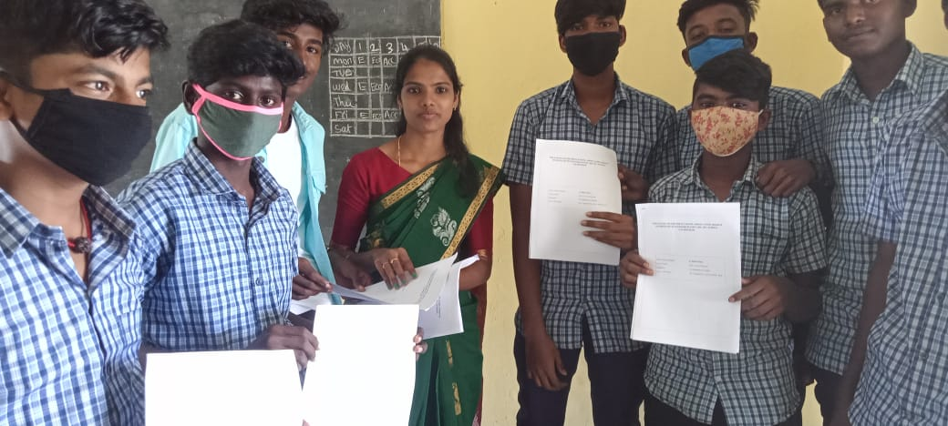

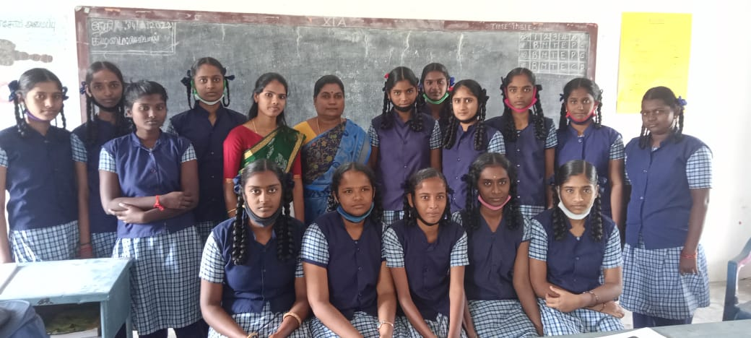

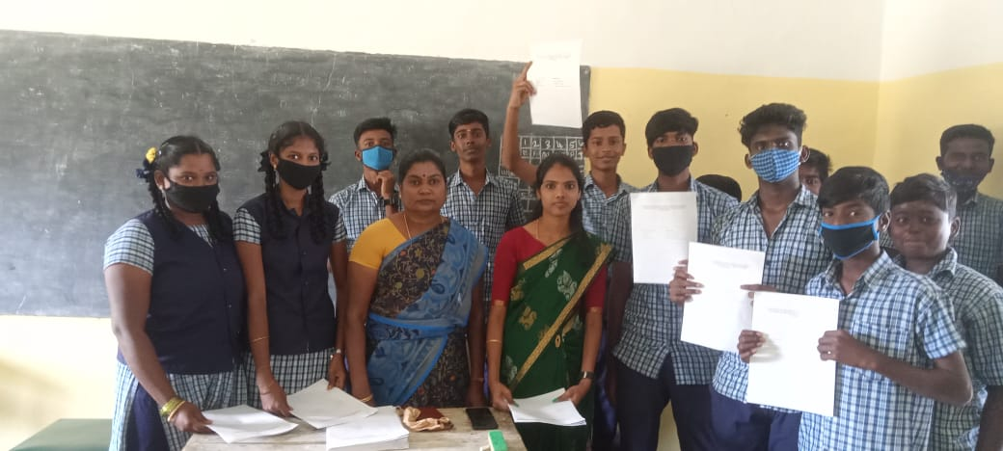



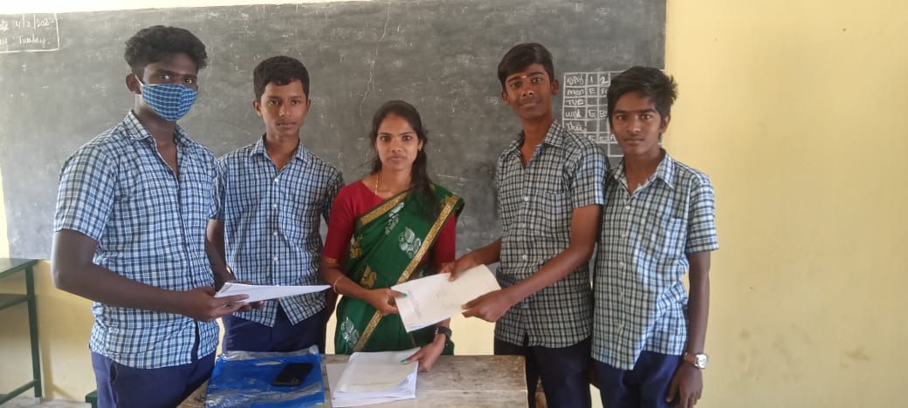



**STATISTICAL ANAYLSIS**

The Problems faced by XI Standard Tamil medium school students in learning English as Compared to other language. A perusal of the depicts that Out of 40 Students, 16 students mentioned that they face difficulty while interacting in English with teachers and classmates whereas 24 students mentioned that they do not face difficulty while interacting in English with teachers and classmates. Out of 40 Students respondents, 26 students mentioned that their English teacher taught English as a subject rather than language whereas 14 students did not agreed. Out of 40 Students, 35 students felt that mother tongue is one of the barriers for learning English whereas 5 students were against it. Out of 40 Students respondents, 30 students admitted that they face difficulty while learning English as compared to other language whereas 10 students mentioned positively. Out of 40 Students respondents, 21 students felt that their subject matter is hardly related to their surrounding environment whereas 19 students responded positively. Out of 40 Students respondents, 20 felt that methods of teaching English adopted in the schools are defective whereas 20 students did not agreed.

**STUDY RESULT**

1. Names of the Students have been collected.
2. Among 40 Students, 29 Students are 15 years old and 11 Students are 16 years old.
3. Among 40 Students, 10 Students belong to ‘A’ group, 16 Students belong to ‘B’ group and 14 Students belong to ‘C’ group.
4. Among 40 Students 18 Students are male and 22 Students are female.
5. Among 40 Students, Studying in Government School.
6. Among 40 Students, Studying in Tamil Medium.
7. When the Students asked choose abbreviation for LSRW. Among 40 Students, 37 Students have chosen option A and 3 Students have chosen option B.
8. The Students are asked which form of English is difficult. Out of 40 Students, 2 Students opted option ‘A’, 10 Students opted option ‘B’, 15 Students opted option ‘C’ and 13 Students opted option ‘D’.
9. The Students are asked whether they Struggle to speak in English. Out of 40 Students, 21 Students opted option ‘A’, 14 Students opted option ‘B’ and 5 Students opted option ‘C’.
10. The Students are asked if they attempted to speak in English before. Out of 40 Students, 9 Students opted option ‘A’, 8 Students opted option ‘B’, 17 Students opted option ‘C’ and 6 Students opted option ‘D’.
11. The Students are asked how they feel talking in English inside the classroom. Out of 40 Students, 6 Students opted option ‘A’, 24 Students opted option ‘B’, 8 Students opted option ‘C’ and 2 Students opted option ‘D’.
12. The Students are asked whether they ask doubts during class hours. Out of 40 Students, 34 Students opted option ‘A’, 1 Student opted option ‘B’, 4 Students opted option ‘C’ and 1 Student opted option ‘D’.
13. The Students are asked whether they secured good marks in English. Out of 40 Students, 30 Students opted option ‘A’, 9 Students opted option ‘B’ and 1 Student opted option ‘C’.
14. The Students are asked if they would like to read and write in English. Out of 40 Students, 20 Students opted option ‘A’, 14 Students opted option ‘B’, 4 Students opted option ‘C’ and 2 Students opted option ‘D’.
15. The Students are asked whether they allot specific time for reading English books. Out of 40 Students, 3 Students opted option ‘A’, 10 Students opted option ‘B’, 18 Students opted option ‘C’ and 9 Students opted option ‘D’.
16. The Students are asked what type of English books they find difficult to read. Out of 40 Students, 1 Student opted option ‘A’, 5 Students opted option ‘B’, 29 Students opted option ‘C’ and 5 Students opted option ‘D’.
17. The Students are asked if they have any idea about going to Spoken English classes. Out of 40 Students, 18 Students opted option ‘A’, 19 Students opted option ‘B’ and 3 Students opted option ‘C’.
18. The Students are asked how they learnt English. Out of 40 Students, 23 Students opted option ‘A’, 1 Student opted option ‘B’ and 16 Students opted option ‘D’.
19. The Students are asked if they feel reading English books help them for other subjects. Out of 40 Students, 28 Students opted option ‘A’, 2 Students opted option ‘B’, 1 Student opted option ‘C’ and 9 Students opted option ‘D’.
20. The Students are asked if they have an idea of choosing English for their career. Out of 40 Students, 19 Students opted option ‘A’, 16 Students opted option ‘B’, 4 Students opted option ‘C’ and 1 Student opted option ‘D’

**IMPLEMENTING THE SOLUTION**

The study finds several contributing factors in learning English as a subject among Tamil medium students. The ESL students feel confident only when they emerge successful in English examination. It clearly makes a huge impact in learning other subjects. The results of this study are meaningful in several ways. With this information, the ESL teachers and coordinators will be better informed about the attitudes towards and instruction of ESL students in the all English classroom and be provided with an understanding of all English classroom teacher views concerning language acquisition and the subsequent instruction aligned with these views. Also this study informs ESL teacher educators about the strengths and weaknesses of ESL students.

This analysis shows whether the ESL teachers or experts in the field actually reflect what researchers say needs to be and should be done in assisting equal education for ESL students along with the students who pursue all the subjects in English. In some areas, the teachers need to make changes in instruction but do not know how to do so.

The all-English classroom teachers have varied understanding of how language is acquired and developed. They do not see the all English classroom as a rich source for intellectual and language development. Most of the all English classroom teachers place a large amount of responsibility on the ESL atmosphere in classroom.

This study shows that much work needs to be done in the preparation of ESL students to participate in the classroom activities. They look at the English only as a subject and do not understand the existing connection between English and other subjects. Various factors contributing to the difficulties they face. Unlike the students who study in English medium and matriculation schools, the Tamil medium students do not expose to the language and its vocabulary and proper pronunciation.

**This study shows some of the specific challenges that ESL students face when learning English**

1. An abundance of idioms and figurative language in English texts.
2. Density of unfamiliar vocabulary.
3. Using of homonyms and synonyms.
4. Grammar usage especially the “exceptions to the rules”.
5. Word order, sentence structure and syntax.
6. Difficult text structure with a topic sentence, supporting details and conclusion.
7. Unfamiliarity with the connotative and denotative meanings of words.
8. ESL may not have practice in expressing an opinion about texts.
9. Using of typical regional English dialects.
10. Fear of participation and interaction with mainstream students.
11. Story themes and endings can be inexplicable.
12. Literary terms for story development are not understood.
13. Unfamiliarity with drawing conclusions, analyzing characters and predicting outcomes.
14. Imagery and symbolism in texts are difficult.
15. The authoritative and restricted classroom atmosphere with less participation.
16. With the above stated difficulties common among all the students who pursue English as a Second Language, this study offers the following suggestions.
17. To create a healthy discussion among students before getting started.
18. Speak clearly, naturally and avoid using lots of slang.
19. Ask students to repeat what you have just said to show understanding.
20. If the students have trouble to understanding the lesson, the teacher must rake specific care in writing down what he/she is saying.
21. Using lots of repetition and plenty of examples.
22. Putting everything into context. The correction must be done simultaneously.
23. Encourage each student to take active part of English learning. There should be “equal time” for the students to talk or ask questions and it is sometimes easy to forget to stop and wait for the questions to be formulated. Sometimes the instructor needs to wait in silence before a question gets asked.
24. Encouraging the students to make friends outside of class because this will improve their English.
25. If put it into practice, surely the ESL atmosphere will help to improve the Tamil medium students to get good marks in other subjects.

**CONCLUSION**

The investigator had been to Government Higher Secondary School Valarpuram to investigate XI Students level felt that sufficient time was not provided to them in teaching English. It is important for learning English as a second language. English should be practiced for as long hours as possible. The language learners need to realize the delicacy of the process involving the language learning and so they have to cultivate, organize and develop their skills in speaking and writing as well on their own, independent with the guidance provided if any. They stressed mostly and using workbooks and other reference material for learning English language.

Some Student respondents agreed that teachers correct their notebooks in classrooms while other did not agree. They felt that reading poetry helps them in improving pronunciation in English language. Many of Student respondents also agreed that learning of English is tough as compared to other language. Majority of the students considered English is a easy subject because of the methods used by the teachers and the usage of library, what’s app and news papers help them to improve their English fluency.